**A logistic regression analysis on predictors of political participation amongst Philippine mainline Protestant church-members in anti-coastal reclamation movements: The case of Bacolod City, Negros Occidental**

Jericho A. Trio

*University of the Philippines- Visayas*

**Abstract**

The Banago Coastal Reclamation Project is a 247-hectare reclamation initiative in Bacolod City, Negros Occidental proposed in August 2022 which is predicted to displace 6,000 families and damage surrounding mangrove ecosystems lining up coastlines of Banago, Bacolod. The political engagement of religious actors participating in anti-coastal reclamation movements has been evident in opposing such project, particularly in alliance-networks of mainline Protestant churches present in the area. In mainline Protestantism, the discourse on political participation involves integrating the practice of evangelism on the principles of social justice and ecological well-being. The focus of this study shall hinge on identifying the odds of political participation amongst mainline Protestant church-members in anti-coastal reclamation movements using logistic regression analysis. The study is only limited in exploring increments of political participation on five Bacolod mainline Protestant churches—the Convention of Philippine Baptist Churches, United Church of Christ in the Philippines, United Methodist Church, Philippine Independent Church and the Salvation Army. The assumed predictor variables are personal resources, political motivational factors, group membership and demographic proximity. The logit model suggests church doctrinal stance (under the category of political motivation factors), is the only predictor which expresses a significant parameter for comparing the Political Participation (Yes) group versus the Political Participation (No) group. A one-unit increase in the said predictor is associated with a 1.719 increase in the relative log odds for a mainline Protestant church-member to participate (or not participate) in anti-coastal reclamation movements.

**Keywords**: logistic regression analysis, mainline Protestant, political participation, environmental citizenship

**Word count**: 9.196 words

**1-Introduction**

**Background of the study**

The political engagement of religious actors participating in anti-coastal reclamation movements has been evident particularly in the case of Bacolod City, Negros Occidental on which coastal reclamation were forestalled and confronted by both Roman Catholic and mainline Protestant churches (specifically, the Philippine Independent Church and the United Church of Christ in the Philippines). (Samillano, 2022) In the context of mainline Protestantism, the discourse on political participation would involve integrating the practice of evangelism on the principles of social justice and ecological well-being. (Aoanan, 2009; 84)

The focus of this study shall hinge particularly on the parameters of identifying predictors of political participation amongst church-members in mainline Protestant denominations in anti-coastal reclamation movements. To account, mainline Protestant churches convey a long history of socio-political struggle and engagement which sets them apart from other Protestant groups. In the Philippines, the umbrella organization for mainline Protestant churches is the National Council of Churches in the Philippines. (NCCPhils.org). Relative to the practice of coastal reclamations, NCCP has been steadfast on its advocacy on environmental protection and is in opposition to endeavors that could jeopardize the environment (i.e., large-scale mining, reclamation, etc.,). (dcmiphil.org).

**Research Problem**

This research aims to identify the odds of political participation amongst Philippine Mainline Protestant church-members, particularly in the context of anti-coastal reclamation movements. It should be noted that while the National Council of Churches in the Philippines would often express a progressive take on theology and has released critical statements on pressing Philippine social and political issues; stances within its member mainline Protestant denominations can vary. Considering such gap, the following research questions are formulated:

1. What are the odds that demographic proximities, personal resources, political motivational factors, and group networks will predict Bacolod-based mainline Protestant church-members to participate in anti-coastal reclamation movements?
2. What relationships exist between demographic proximities, personal resources, political motivational factors, and group networks in anti-reclamation movements among Bacolod-based mainline Protestant church-members?
3. What is the best model to predict political participation of mainline Protestant church-members in anti-coastal reclamation movements?

**Scope and Limitation**

This study is concerned only in finding the odds of political participation amongst mainline Protestant church members in anti-coastal reclamation movements within the study local of Bacolod City, Negros Occidental. The researcher was limited to examining relationships between predictors and the response variable (political participation). Political participation shall be limited to mainline Protestant church-member participation in anti-coastal reclamation movements as well as in rallies and picket mobilizations.

The researcher has identified five mainline Protestant denominations which are present and common in the research settings, mainly--- the Convention of Philippine Baptist Churches, the United Methodist Church, the United Church of Christ in the Philippines, the Salvation Army and the Philippine Independent Church (Aglipayan). The study shall not include mainline Protestant denominations which are not present in the study locale.

**Significance of the Study**

The result and findings of this study on determining the odds for political participation amongst mainline Protestant church-members in Bacolod City, Negros Occidental provided significant details and insights which may benefit to the following:

**Students of psychology, sociology and political science**. The results of the study will help students of psychology, sociology and political science to utilize regression modelling in identifying predictors of a particular political phenomenon. The pursuit of quantitative methods in the research instruments may give students in the mentioned disciplines of the social sciences confidence in their craftsmanship of correlational and predictive statistics as well as the utility of quantitative social science instruments on their research endeavors.

**Students of statistics**. The results of the study will help students of B.S. in Statistics on integrating statistical instruments in the disciplines of psychology, sociology and political science. For instance, regression modelling and analysis, which is the key research instrument of the study is useful on identifying variable weight and relationship with a particular outcome. The study can help statistics students to explore instruments that can be applied in social science.

**Researchers of environmental citizenship and political participation**. The results of the study can provide additional knowledge in research and literature on environmental citizenship and political participation. Considering how the study has provided variables distinct in the context of mainline Protestant church-members, identified predictor variables can help researchers of environmental citizenship and political participation to explore further church-based and religious institutions particularly in environmental activism and participation in anti-coastal reclamation activities.

**Mainline Protestants and faith communities**. The results of the study can help raise awareness on mainline Protestants and other faith organization on why churches carry an increment to participate in anti-coastal reclamation activities. As such, it can provide avenues of discussion on the niche of churches in engaging on issues which plague ecological welfare and environmental arrangements.

**2-Review of Related Literature**

**Political Participation and Mobilization**

The following section of the review of related literature shall tackle perspectives on political participation. It is crucial to consider beforehand how political participation derives its outset on group consciousness. Contending how group consciousness occurs under complex arrangements, Arthur Miller and his colleagues assert four dimensions prior to its conception, mainly, (i) group identification (linkages of inclusiveness and loyalty forged in a particular social class, economic circumstance or groups and individuals sharing similar traits and characteristics), (ii) polar affect (an inclination to be preferential in one’s ingroup and differential to outgroups), (iii) polar power (contentment and discontentment on the group’s contemporary status) and (iv) a tendency to system blame. (Miller et al., 1981; 495-496) Relative to approaches that could outsource the development of political participation, Miller suggests two approaches, mainly an additive approach (which sees political participation as a cumulative phenomenon that increases as social cleavages continue to amplify) and subordinate groups model (in which groups belonging within subordinate or marginalized aggregates of society collectively mobilize to contest systemic problems which may be attributed to their plight). (Miller, 1981; 500)

Considering how political participation occurs as an exchange between group consciousness and pressing socioeconomic circumstances, researchers understanding the occurrence of such phenomenon need to acknowledge how political participation exists in different activities, including--- voting, lobbying, staging rallies and protest as well civil society endeavors. (Potgieter, 2013; 23) Moreover, increments of contention in political participation lays on variability of conflict and levels of pressure exerted by mobilizing groups towards a particular target point---- usually government structures--- of whom have the capacity to address existing concerns and craft necessary solutions. (Dalton, 2008; 24) Carrying the same sentiment on how contention relates to degrees of political participation, Hanspeter Kriesi argues how increments of political mobilization are dependent on the depth of crises a particular collective may experience. The permutations of these crises can span from socioeconomic conflict (e.g., economic recession and loss of job opportunities) to ecologically-and-resource based concerns (e.g., displacement from native residence which can affect an individual’s access to resources). To cite support for his assumption, Kriesi utilized historical events such as the Great Depression in the United States which amplified the growing interest to participate in labor unions. The gravity of the crisis activated key civil society actors spanning from labor unions, mainline churches, and urban poor organizers--- to collectively demand for economic justice in such a period characterized by crisis and uncertainty. (Kriesi, 2015; 19-21)

**Context of Anti-Coastal Reclamation Movements in Bacolod**

The following section of the review of related literature shall introduce the cases of recent coastal reclamation initiatives (and corresponding anti-coastal reclamation movements) on the two-year increments of 2021 and 2022 within the locus of Bacolod City, Negros Occidental. Context of these phenomena will be crucial to situate the dynamics and associated arrangements in the conduct of the study.

To begin, in the case of Bacolod City, Negros Occidental, the anti-coastal reclamation alliance “Banago Against Reclamation Movement (BARM)” is a collective response of church people, fisher-folk and human-rights based mass organizations prior to Bacolod City-Councilor Vladimir Gonzales’ proposed 247-hectare reclamation project in Barangay Banago. To account, the proposed reclamation initiative would displace 6,000 families and deprive them from their economic livelihood. Moreso, lacking necessary permits from the Department of Environment and Natural Resources (DENR), Philippine Reclamation Authority (PRA), Bureau of Fisheries and Aquatic Resources (BFAR), Philippine Ports Authority (PPA), the coastal reclamation initiative can be detrimental to surrounding coral reefs and mangrove ecosystems which line-up the coastlines of Banago, Bacolod City. (Ledesma, 2022) Prior to church denominations present, both parishes of the Iglesia Filipina Independiente (Philippine Independent Church) and the Roman Catholic diocese of Bacolod City were key participants in the launching of BARM.  Relative to temporal scales, the movement was initially launched on September 11, 2022.

**Psychological Proximity Hypothesis and Sociopolitical Attitudes**

Aaron Sparks (2017) in his dissertation, “Reducing Distance to Increase Action: How psychological proximity drives political activism”, introduces psychological proximity hypothesis as an assumption to explain increments of political participation in a group or an individual. The said hypothesis states that when an issue is proximate, people are more likely to participate in political activism on an issue. (Sparks, 2017; 5) It is crucial consider how psychological proximity in Spark’s hypothesis is a predicate on an individual or group’s decision to engage in political activism. Using the rhetoric on likelihood on psychological proximity, Spark provided the following examples: (i) a nuclear plant could be slated for approval, may compel an individual whose community is of nearer proximity to the nuclear plant site on becoming an anti-nuclear activist and (ii) a school shooting may occur, whose aftermath may concur community individuals to be advocates for a stricter gun access law. (Sparks, 2017; 5) Clearly, people are more inclined to take a specific action, when presented with one, because they are able to observe the linkages between a concrete problem and a specific action that addresses it. To illustrate Spark’s hypothesis, an individual whose proximity is nearer in the vicinity of the problem being faced (within the range of five to ten kilometers) would more likely to participate in political activism relative to an individual whose vicinity is farther from the site (exceeding ten kilometers or more).

**Socio-ecological engagement and political participation in Mainline Protestantism**

The conception of an-ecological justice-based theology draws a cumulative endeavor of the social gospel movement as it links biblical analysis to exchanges which occur between nature-and-society. Particularly it has been advocated by Presbyterian and Protestant Episcopal ministers such as Rev. Dough Hunt of whom placed the need to extend the “justice mission” of the church to discussions concerning environmental protection and sustainability. (Moody, 2003; 240) Such initiative would lead to the development of environmental task forces amongst mainline Protestant churches such as the Eco-Justice task force of the Presbyterian Church and the Baptist Association, the Department of Environmental Justice and Survival of the United Methodist Church and the inclusion of “sacred ecology” in the prayer books of the Protestant Episcopal Church (Moody, 2003; 242)

Prior to the Philippine setting, the umbrella organization of mainline Protestantism---- the National Council of Churches in the Philippines has been critical relative to ecological issues particularly on deforestation, coastal reclamation, and open-pit mining. Relative to member-based commitment on ecological justice, the United Church of Christ in the Philippines (a communion of five indigenous Philippine mainline Protestant churches--- the Reformed Church, the Congregational Church, the United Brethren, the Philippine Methodist Church and the Presbyterian Church) has released in its 1990 assembly, a primer on ecological justice entitled,  "The Church for the life of the World: Called to be Stewards of God's Creation", the following statement reiterated the need for a church to “prophetically” witness and participate on concerns which plague both society and ecology. (Aguilan, 2016; 8) Such ethos has also been evident, in the case of the Philippine Independent Church (Iglesia Filipina Independiente), of whom in its 2011-2014 General Framework emphasized the need for its parishes to sustain participation on coalitions which struggle for ecological welfare. (IFI, 2011) Prior to the Lutheran Church of the Philippines, the mainline denomination has been active in mobilizing its churches particularly the youth sector (the Philippine Lutheran Youth League) in the quest for environmental justice and eco-responsibility by integrating environmental themes on church curricula and liturgy. (Weyermüller, 2020)

**3-Conceptual Framework**

**Theoretical Approaches of Predictors for Political Participation**

The generalized nature of these approaches makes it possible for the researcher to narrow down the research topic, making it possible in the process, the probability of identifying points on which he or she can intervene upon. Particularly, the researcher has identified two frameworks which are prevalent on predictor and correlation studies on political participation (Dalton, 2008; Potgieter, 2013; Putnam, 2000) mainly--- social capital approach (SCA) and civic volunteerism model (CVM). The structure of this section shall provide a quick overview on the mechanism of how each framework operates and identify its existing limitations.

These approaches will be crucial in providing a need to grasp the dynamics on how and why mainline Protestant churches participate in anti-coastal reclamation movements. Understanding increments of participation of the study interest will be crucial to assess if variability across mainline Protestant denominations is existent, as well as factoids that could influence their degree of engagement. Relative to the contribution of the study in the discipline of political science, identifying predictors of political participation amongst mainline Protestant denominations in anti-coastal reclamation movements can provide additional perspectives on environmental citizenship (particularly the niche played by mainline churches). In essence, environmental citizenship is the growing increment of social consciousness and responsibility of citizens within the exchanges which occur between nature-and-society. (Karlsson, 2012; 460) It recognizes the need to acknowledge the existence of nature-and-society interactions as means to “materialize” policy-making and ecological reforms in the direction of local communities. Themes related to environmental citizenship include a deeper grasp on sustainability, ecological justice, and the capacity to strategize measures that mitigate risk.

**Social Capital Approach**

Seeing the nexus of society as a network assemblage with associated social algorithms, Robert Putnam defines social capital as an increment of “trustworthiness” that “arises” amongst interactions between individuals and existing social networks. (Putnam, 2000; 19) It is crucial to consider how Putnam utilizes the verb “arise” to depict the dynamics of trustworthiness within social aggregates as if to imply how the conception of social capital is a cumulative endeavor which builds up over time. It is within such an arrangement, that Putnam frames his social capital approach, in which social networks are considered as a key variable that could affect the behavior of groups and individuals within an existing collective or the very realm of society. (Putnam, 2000; 18) Utilizing correlations to frame his argument, Putnam (1993) contends how societies with high increments of individuals participating in social and civic activities are more probable to be trustworthy and successful relative to societies whose increments of participation are lower. Moreso, a positive correspondence between trust levels and socio-civic engagement provides the likelihood for higher intensities of political mobilization and activism.

Despite of its capacity to draw relationship between variables (e.g., how levels of political activism is dependent to increments of trust levels and socio-civic engagement), critics of the approach contend how the utility of the word “capital” in the phraseology of the approach diminishes the value of Putnam’s social capital particularly in the black-and-white areas of judgements rooted on morality and immorality. For instance, such an argument is visible to Michael Cohen’s concept of a “neutral” social capital. (Cohen, 2000; 221) To account, Cohen flags social capital as neutral since it occurs under the arrangement of direct interpersonal exchanges between social networks and economy. Moreso, social capital is simply a resource whose utility is constrained in attaining social coherence to prospects which are associated often with morality such as social justice or equity.

**Civic Volunteerism Model (CVM)**

The conception of civic volunteerism model (CVM) derives heavily on the works of Henry Brady, Sidney Verba and Kay Schlozman (1995) flags the approach beforehand as a “resource model” to determine the nature of political participation. To account, the following model contends how permutations on political participation are inclined by resource availability within the parameters of an individual. These resources could range from an individual’s characteristics such as existing generational gaps, gender, religion, geography, and ethnicity. (Brady et al., 1995; 271) The model tackles three variables------ mainly an individual’s economic resources (social status and educational attainment), demographics, political interest and increment to engage in socio-civic activities as main predictors for political participation. Such is further utilized in the study conducted by Russel Dalton’s (2008) study on citizen politics within the arrangements of advanced industrial democracies, where he considers “associational networks” expressed within the parameters of religion, ethnicity and geography as facilitators that can further amplify political participation. Moreso, the existence of uncertainties and the necessity to address such pressing concerns envelopes a heightened atmosphere of socio-civic and political engagement. (Dalton, 2008; 58, 161)

Prior to its general take of predictors that can influence political behavior and increments of engagement, the model expresses its limitations on not having the capacity to consider variables which may possibly impact an individual’s political choice to participate. (Potgieter, 2013; 39) Despite such, it garners an appropriate framework for quantitative research since it gives the researcher the ability in quantifying generalized predictor variables relative to the existence of a particular phenomenon (in this case political participation).

**Schematic Diagram and Discussion of Key Variables**

A conceptual framework in research serves as a direction instrument that a researcher uses to generally determine theories and corresponding methodologies for the current research project. To account, the following framework (see Figure 3.1) is structured as a proposed original model (POM) depicting the summarized civic volunteerism model (which contains both predictor and response variables, on the right side of the framework).

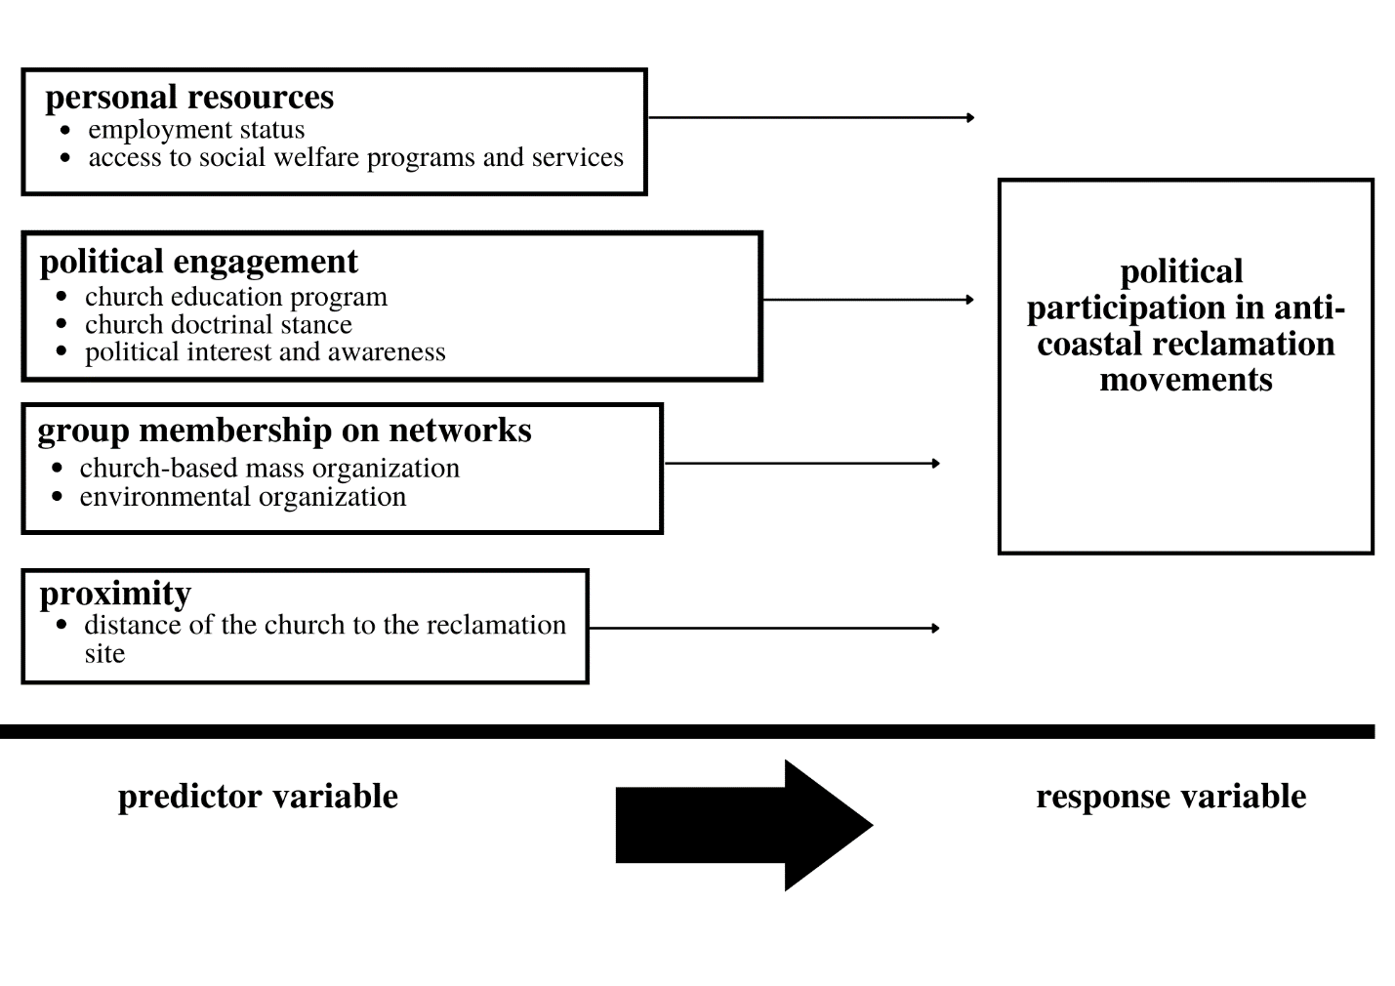

**Figure 3.1**Schematic diagram of the study

**Predictor and Response Variables of the schematic diagram**

It is crucial to consider beforehand how a response variable is a variable which is to be observed while a predictor variable is a variable which is used to explain the values of a response variable. Civic volunteerism model considers social and psychological aspects as means to predict and determine increments on why people participate in political activities. Moreover, the said approach takes into account the significant niche of citizen engagement in a political system. (Potgieter, 2013; 30) As such, the model identifies four predictor variable categories for political participation mainly (i) personal resources, (ii) political engagement, (iii) group membership on networks, and (iv) demographics. Prior to element predictors within the study interest on participation amongst Philippine Mainline Protestant church-members in anti-coastal reclamation movements of Bacolod City, Negros Occidental, the researcher of the study pursued the following limits: (i) for personal resources----employment status and access to social welfare programs and services, (ii) for political engagement-----the nature of church education programs and church doctrinal stance, levels of political interest and awareness (iii) group membership on networks---- church-based mass organization and environmental organization (iv) for proximity--- distance of the church to the coastal reclamation site. Correspondingly, the response variable shall be political participation. The linear direction of the arrows in the schematic diagram depicts the dynamics of the mentioned predictor variables to the response variable of the study. The researcher of this study has attempted to contextualize these variables in the research interest of mainline church-members’ participation in anti-coastal reclamation movements. Moreso, the pursued element predictor variables were identified as to be distinct from recurring literature on political participation.

**4- Methodology**

**Research Design**

The study utilizes the quantitative descriptive-regression analysis research design. This research design relies on the collection and analysis of numerical data as means to describe, explain, predict, or control variables and phenomena of interest (Mills and Gay, 2019; 361). Considering how the research design is non-experimental since its object of focus is on predictions; conclusions drawn from the study are descriptive.

**Sampling Method**

The following study utilized a stratified random sampling as its instrument for sampling method. The method has been applied as a forthright probability sampling instrument since it only involves a division of a population into smaller subgroups known as strata sharing homogeneous characteristics. (Mills and Gay, 2019; 191) Prior to its capacity to obtain higher chances of a representative sample, stratified random sampling ensures that every individual has equal chances once to be selected (in its utility of conducting a simple random sample once the population has been divided into strata) and how the selection of such individual does in no way affect the selection of another individual.

**Respondents of the Study**

To explore this research, the researcher of this study focused its respondents within church-members of mainline Protestant denominations in the locale of Bacolod City. Moreso, stratified random sampling as the method of application established by the researcher randomly choosing a proportional subset from the sample size total of 149. The sample size was obtained using Slovin’s formula with an eight percent margin of error.

**Table 4.1**.*Distribution of Respondents in Bacolod City, Negros Occidental (At Eight Percent Margin of Error)*

|  |  |  |  |  |
| --- | --- | --- | --- | --- |
| **Mainline Protestant Denomination** | ***f* (population)** | **%** | ***f* (sample)** | **%** |
| Convention of Philippine Baptist Churches | 10,954 | 52.43% | 78 | 52.34% |
| United Methodist Church | 29 | 0.13% | 1 | 0.67% |
| Salvation Army | 62 | 0.29% | 1 | 0.67% |
| United Church of Christ in the Philippines | 8,632 | 41.32% | 61 | 40.94% |
| Philippine Independent Church (Aglipayan) | 1,215 | 5.82% | 8 | 5.36% |
| Entire group (Σ) | = 20, 892 | = 99.99% ≈ 100% | = 149 | =100% |

**Plan for Data Analysis**

*Descriptive Analysis*

Frequency distribution tables and bar-plots were utilized to depict the respondent in terms of the predictor and response variables of the study.

*Bivariate analysis*

To address the research problem on relationships which exist between predictor and response variables, bivariate analysis was utilized as quantitative instrument. Scatterplots and correlation coefficients were employed to determine the association of the dependent variable with each numerical independent variable. Moreover, independent samples t-test was utilized to compare the response variables.

*Logistic regression analysis*

Logistic regression is the appropriate regression analysis to conduct when the response variable of the study is dichotomous (binary). As an instrument of regression analysis, the logistic regression is predictive. Logistic regression is utilized both to describe data and to explain the relationship between one dependent binary variable and one or more nominal, ordinal, interval or ratio-level independent variables. (Kleinbaum and Klein, 2010) Moreso, the regression instrument is a statistical model that models the probability of an event taking place by having the log-odds for the event be a linear combination of one or more predictor variables. (Tolles and Meurer, 2016; 533-534) The said data instrument would involve the use of: (i) coefficients (strengths and directions of relationships between two or more variables) and (ii) beta-weights (the expression of influence of each predictor variable, which enables the researcher to assess relative importance of each predictor). (Potgieter, 2013; 74)

**Significance of Predictor Variables**

The Wald Test (also referred to as Wald Chi-Squared Test) is a parametric statistical instrument utilized both to confirm a set of predictor variables are indeed collectively significant for a model. A predictor variable is significant if and only if such variable adds an incremental value to the model. As such, variables which fail to add value to the model are omitted. Wald test utilizes the parameter’s sample estimate and an estimate of variability to obtain conclusions about the unobserved true value of the parameter. (Baum, 2006) Moreover, in the lens of logistic regression, Wald test is used to compare models on best fit. This technique is used to determine ‘significant’ variables from the set of predictors used in to an array of models with binary variables or models with continuous variables. Wald statistic can be stated as:

$$z=\frac{\hat{β}}{SE}$$

Where:

* $\hat{β}$ is the coefficient in the model
* SE is referred to the standard errors
* z is the Wald statistic with a chi-squared distribution

**Model Diagnostics**

As means to determine the candidate models, possible models were examined through a set of diagnostic checking procedures. If a specific model violates one of the assumptions, it is rejected from the pool of candidate models. The following procedures would be crucial in answering the third research question of this study. The table below summarizes the procedure.

**Table 4.2.** *Diagnostic Checking Procedures and Formal Tests*

|  |  |
| --- | --- |
| Assumptions | Diagnostic Checking |
| Goodness of fit | Hosmer-Lemeshow Test |
| No influential outliers | Cook’s Distance Measure |
| No covariate is a perfect linear function of any other covariates (multicollinearity) | Generalized Variance Inflation Factors |
| No indication of overdispersion in data | Overdispersion Ratio Test |

**Supplemental Methods**

*Key informant interview*

Key informant interviews are in-depth discussions with persons who are knowledgeable about a particular issue or problem that a community is trying to solve. Open-ended questions are used in semi-structured interviews to elicit information on specific subjects. Additionally, they give respondents the chance to consider their own habits and presumptions as well as add material based on their own knowledge and opinions. When adopting less organized or predetermined data collection methods, such as interviews with key informants, new areas of interest and new knowledge may be discovered. Key-informant interviews were utilized to give support on the analyzed data from logistic regression. The researcher of the study conducted a purposive sampling and a set of interview questions on key persons within the focus mainline Protestant denominations of the study locale. One key-informant was purposively chosen from each mainline Protestant denomination in Bacolod City, Negros Occidental. As such the following criterion is structured:

|  |  |
| --- | --- |
| **Criterion** | **Rationale for criterion** |
| A church minister or a church worker of a mainline Protestant denomination | Such criterion was chosen in order to contextualize theological dynamics on each mainline Protestant denomination |
| A church member of a mainline Protestant denomination residing in Bacolod City, Negros Occidental | Such criterion was chosen in order to situate within the current coastal reclamation in the locale of the study |
| A leader or any member of church-based mass organizations in the Banago Against Anti-Reclamation Movement (BARM)  *Regional councils of the National Council of Churches in the Philippines | Such criterion was chosen in order to consider groups and individuals of whom express political participation either in socio-civic action and protest mobilizations |

The structured questions in the key-informant interview were patterned to complement the quantitative survey questionnaire and the research questions of the study.

**5-Results and Discussion**

**Logistic regression analysis**

A multiple logistic regression was performed to model the relationship between the predictors and the political participation of the church-goers (whether yes or no). The conventional 0.05 criterion of statistical significance was employed for all tests. Addition of the predictors to a model that contained only the intercept significantly improved the fit between model and data, Chi-square test showed (df=9, N = 149) = 85.4, Nagelkerke R-squared = 0.584, p < .001. As shown in Table 5.1, significant specific contribution was made by Church-doctrinal stance. Goodness of fit was explored by conducting Hosmer-Lemeshow test which resulted to a non-significant results of Chi-square test showed (df=8, N=149) = 2.548. The results would imply that the multiple logistic regression model is a good fit.

The reference group was those church-goers who said YES to political participation. Accordingly, each predictor has one parameter which is for predicting membership in the “No” group rather than the “Yes” group. To facilitate the interpretation of differences among continuous predictors, each of the predictor variables had been standardized to mean 0, standard deviation 1. The parameter estimates are shown in Table 5.2.

**Table 5.1**. *Predictors’ Contributions in the Multiple Logistic Regression (N=149)*

|  |  |  |  |
| --- | --- | --- | --- |
| **Predictor** | **Test Statistic** | ***df*** | ***P*** |
| Employment status | 1.314 | 1 | 0.252 |
| Proximity | 2.685 | 1 | 0.101 |
| Access to social welfare programs | 1.299 | 1 | 0.254 |
| Church-based mass organization | 2.108 | 1 | 0.147 |
| Environmental organization | 0.176 | 1 | 0.675 |
| Political awareness | 2.117 | 1 | 0.146 |
| Political interest | 0.202 | 1 | 0.653 |
| Church education program | 0.428 | 1 | 0.513 |
| Church-doctrinal stance | 7.654 | 1 | 0.006 |

Only one predictor had a significant parameter for comparing the Political Participation (Yes) group versus the Political Participation (No) Group. For each one standard deviation increase in Church Doctrine, the odds of being in the Political Participation (Yes) group rather than the Political Participation (No) group are multiplicatively increased by 1.223. Taking into account only the base rates of group membership, one would predict, for every case, membership in the Political Participation (Yes). This would result in 55.0% of such predictions being correct. Using the logistic model to make such predictions results in 81.9% correct prediction. Correct predictions were more frequent for the Political Participation (No) group (85.1%) than the Political Participation (Yes) group (79.3%).

**Table 5.2**. *Parameter Estimates Contrasting the Political Participation (Yes) group versus Political Participation (No) group. (N = 149)*

|  |  |  |  |  |
| --- | --- | --- | --- | --- |
| **Predictor** | **Political Participation (YES) VS (NO)** | ***B*** | ***OR*** | ***p*** |
| Employment status | NO | 0.612 | 1.844 | 0.252 |
| Proximity | NO | -1.45 | 0.235 | 0.101 |
| Access to social welfare programs | NO | -0.548 | 0.578 | 0.254 |
| Church-based mass organization | NO | 0.823 | 2.276 | 0.147 |
| Environmental organization | NO | 0.236 | 1.267 | 0.675 |
| Political awareness | NO | 0.948 | 2.58 | 0.146 |
| Political interest | NO | 0.308 | 1.361 | 0.653 |
| Church education program | NO | -0.381 | 0.683 | 0.513 |
| Church-doctrinal stance | NO | 1.223 | 3.399 | 0.006 |

The researcher also culled the model to exclude all predictors that did not have significant specific effects on the response variable. The resulting model was statistically significant, Χ2 (1) = 73.604, Nagelkerke R2 = 0.522, p < .001. The overall percentage of correct classifications increased, to 83.9%. Correct predictions were more consistently frequent for the Political Participation (No) group (89.6%) than the Political Participation (Yes) group (79.3%) which remained the same. Similarly, the Goodness of fit was explored by conducting Hosmer-Lemeshow test which resulted to a non-significant results of Chi-square test showed (df=6, N=149) = 4.769. The results would imply that the multiple logistic regression model is a good fit.

As shown in Table 5.3, Church doctrine remained a consistent predictor variable between Political Participation (YES) and Political Participation (NO). Hence, the final model is:

$$\ln\left(\frac{p}{1-p}\right)=-3.649 + 1.719X , p =\frac{e^{-3.649 + 1.719X}}{1+e^{-3.649 + 1.719X}}$$

**where X is the Church Doctrine Variable**

In this final model, it can be observed that a one-unit increase in the variable church doctrine is associated with a 1.719 increase in the relative log odds of being in a Political Participation (Yes) group versus Political Participation (No) group.

**Table 5.3**. *Parameter Estimates for the Reduced Model (N = 149)*

|  |  |  |  |  |
| --- | --- | --- | --- | --- |
| **Predictor** | **Political Participation (YES) VS (NO)** | ***B*** | ***OR*** | ***P*** |
| Church-doctrinal stance |  | 1.719 | 5.580 | 0.000 |
| Intercept |  | -3.649 | 0.026 | 0.000 |

**Spearman Rho correlations for bivariate analysis**

Spearman’s rho correlation analysis was utilized considering how the data-set has ranked Likert data. The following heat-map below (see Figure 5.1) displays the Spearman’s rho of each pairwise variable. To account, pairwise correlations are significant if p < 0.05.

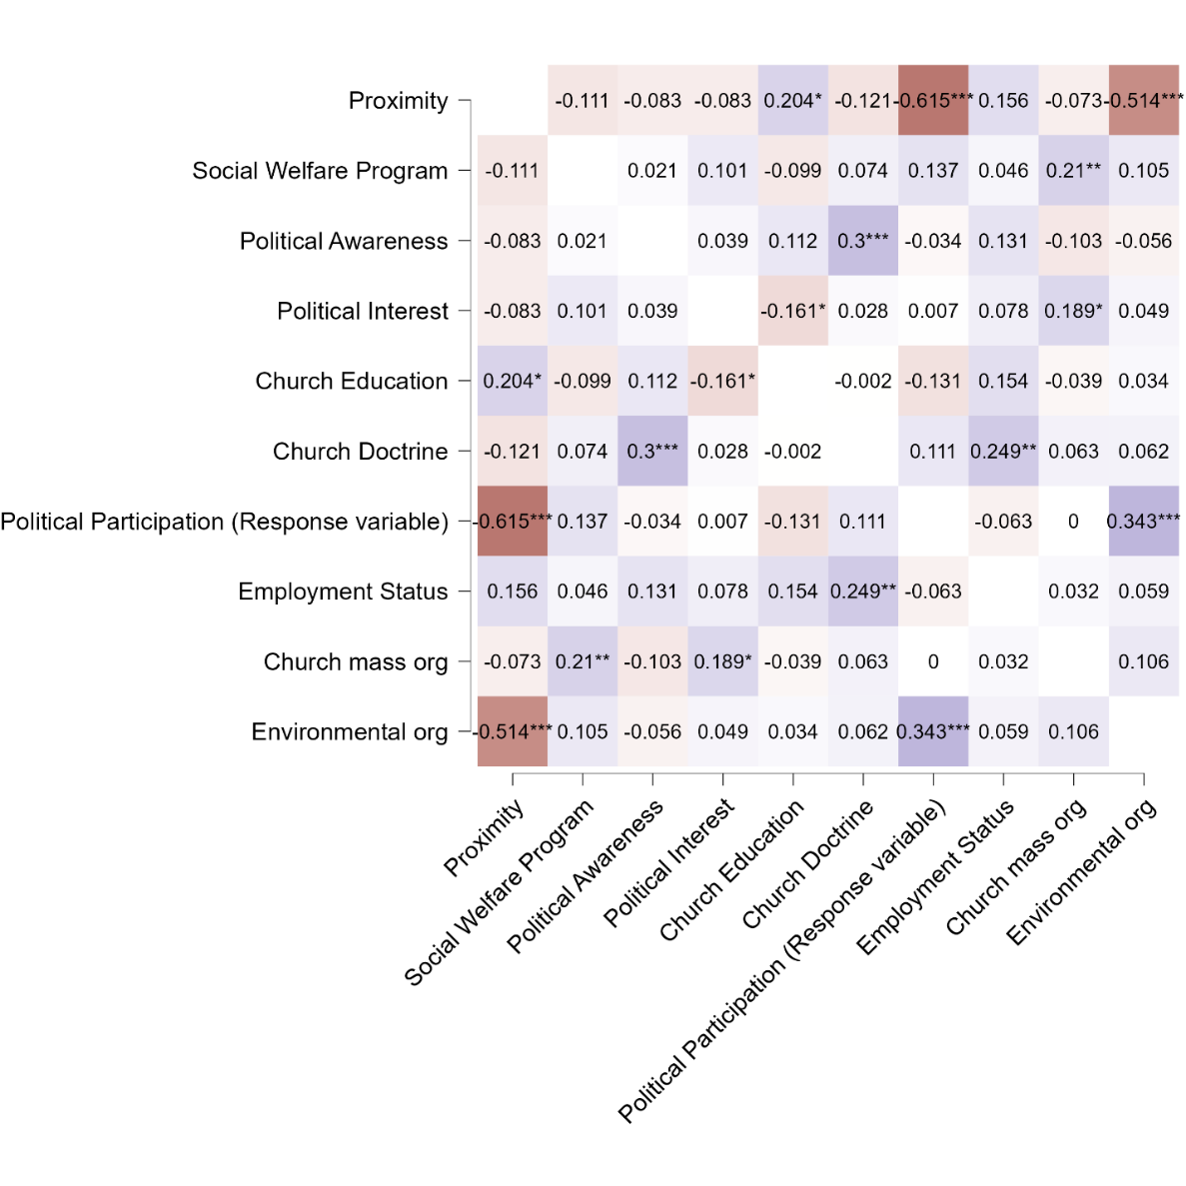

**Figure 5.1** Heatmap of Spearman’s Rho correlations

At p < 0.05, the following pairwise Spearman correlations are significant: (i) church education *x* proximity, (ii) church education *x* political interest, (iii) membership in a church mass organization *x* political interest, (iv) proximity *x* church education, (v) political interest *x* church education, (vi) political interest *x* membership in a church mass organization. Table 5.4 provides a summary of the pairwise correlations and their corresponding relationship:

**Table 5.4** Relationship of pairwise Spearman Correlations at p < 0.05

|  |  |  |
| --- | --- | --- |
| *Pairwise Spearman Correlations* | *Relationship* | *P* |
| Church education program *x* proximity | Direct relationship | 0.013 |
| Church education program *x* political interest | Inverse relationship | -0.161 |
| Membership in church mass organization *x* political interest | Direct relationship | 0.021 |

**The posture of qualitative predictors of mainline Protestant participation in anti-coastal reclamation movements**

*Christian witness and duty*

Based on the key informant interviews, the sample mainline Protestant denominations of the study express how participation in anti-coastal reclamation movements is a Christian imperative on the basis of Christian witness and duty. For the progressive minority in the Convention of Philippine Baptist Churches this is expressed on the need to struggle for just peace against systems and structures that continue to permeate abuse and exploitation; for the United Methodist Church-Philippine General Conference, Christian witness is expressed on God’s love integrated in the cause of social and ecological justice. On the other hand, the United Church of Christ in the Philippines frames Christian witness and duty on the need of the church to educate itself and be consciously aware on pressing realities both in social and ecological settings—clearly, the church should not alienate itself from the basic masses of society. On the other hand, the Philippine Independent Church manifests Christian witness in the context of a spirituality which reconciles an anthropocentric perspective towards an ecocentric one. The Salvation Army places strong emphasis on a Christian witness which meets human needs without partiality—to serve Christ is to serve the people. Relative to the United Methodist Church, the Evangelical Methodist Church of the Philippine Islands orients the Christian witness on the need to challenge a profit-driven economy fueled by capitalism which continues to neglect and damage the environment.

*Recognizing victimization*

The recognition of victimization in sectors and communities directly affected by anti-people and anti-environmental policies such as the coastal reclamation project in Bacolod City, Negros Occidental is a motivation factor considered by the Philippine Independent Church and the United Church of Christ in the Philippines to participate in anti-coastal reclamation movements. For the United Church of Christ in the Philippines—recognizing victimization is a primary step for mainline Protestant churches to enter the crucible of service to the broader masses and release themselves from the comforts of church sanctuaries. On the other hand, the Philippine Independent Church considers the recognition of victimization as crucial in conceptualizing theology within the struggles and experiences of individuals victimized and displaced by coastal reclamation. Vaughn Alviar, a key informant interviewee from the Philippine Independent Church cites an analogy in harvest festivals— “how can the church perform harvest festivals, when the farmer cannot harvest his own field due to El Niño drought and other ecological calamities”—implying the need to develop community-based theologies.

***The direction of political participation of mainline churches in the Methodist tradition***

The study had four mainline Protestant denominations within the Methodist spectrum: the United Methodist Church- Philippine General Conference, the United Church of Christ in the Philippines (an organic union of the Philippine Methodist Church, the Presbyterian Church, the Congregational Church, the United Brethren and Disciples of Christ), the Salvation Army and the Evangelical Methodist Church of the Philippine Islands (utilized for comparison relative to the United Methodist Church). The direction of Methodist spirituality has always intertwined social action and Christian witness hand in hand in evangelism and service. This has been visible in the social principles of these denominations, baptismal vows, and living out the Wesleyan mantra: “The world is my parish”. Referencing on the key informant interviews, mainline churches in the Methodist spectrum have integrated political participation in ecumenical initiative, as expressed in the key informant interviewees from an Evangelical Methodist church worker and a United Methodist minister of whom emphasized “to turn religion into a solitary one is to destroy it” and the need for ecumenical fellowships “to develop local theologies oriented in the experiences of parishioners”.

Mainline Protestant denominations in the Methodist spectrum are politically engaged through alliance-building and the establishment of group networks in challenging policies (not only coastal reclamation) that could harm the environment but place socio-ecological arrangements within the margins of vulnerability. Such feat has included the struggle against Kaliwa Dam construction, the Philippine Mining Act, the defense of ancestral lands of the Mangyans and Lumads as well as integration with urban poor communities, a minister of the United Church of Christ in the Philippines from the key informant interview asserted the need for mainline Protestant churches to go outside their comfortable sanctuaries and enter the crucible of service to the masses. The UCCP minister also emphasized how Christian theology must be linked in the experiences of the urban poor, the peasantry and those who lay within the fringes of Philippine society.

***Continuity and discontinuity in progressive church education programs of Bacolod mainline Protestant churches***

The posture of church education programs and its pedagogy is crucial in rooting the progressive ethos and spirituality of mainline Protestant churches. The Spearman bivariate analysis of the study indicate a significant inverse relationship between progressive church education programs and political interest of mainline Protestant church-members relative to participation in anti-coastal reclamation movements.

Discontinuities of progressive church education programs are expressed in the case of the Convention of Philippine Baptist Churches on which themes on social justice and political participation—such as those articulated in the 1935 Baptist church school material *Eskuela Dominikal*—Speaking the Truth (nagahambal sang kamatuoran); Helping the Poor (nagabulig sa makalolooy); Proclaiming Justice (naga-ampo sa katadlungan ukon katarungan); Corrupt or Abusive Moral and Spiritual Practices (pagpatuyang)—have been absent or minimally integrated in current church education programs. (Bunda, 1999; 193-194) This is documented in the key informant interview with a Convention Baptist minister, “there is an inclination for Convention Baptists to frame church education solely in spiritual matters in the stead of realities which face the realm of society”.

Despite the decline of progressive church education in the Convention Baptists, other Protestant denominations in the mainline tradition persist to view church education as an extension of immersing church members in the crucible of struggle forged continually under pressing sociopolitical, economic and ecological realities. This traces back in the commitment to expression the mission of NCCP whose ecumenical formation was conceptualized in 1963: “*Life in all its Fullness* *is what Jesus Christ lived and died for; life in a just, egalitarian, self-reliant, and sustainable society*”. In the case of the United Methodist Church-Philippine General Conference, church education is perceived as an avenue to perform local theologies framed within the struggles and experiences of the people on which the church is situated. This tone is also carried in the United Church of Christ in the Philippines which has framed church education to be always contextualized for “different folks at different strokes”. On the other hand, for the Philippine Independent Church—church education should always be flexible to socioecological realities—accepting such flexibility as a “relevant way of being church”. With its emphasis on stewardship and acts of service, the Salvation Army perceives church education as a plug-in of doing church mission.

***On Sparks’ psychological proximity hypothesis***

Aaron Sparks’ psychological proximity hypothesis (see Chapter 2) contends how an individual whose proximity is nearer in the vicinity of the problem being faced would more likely to participate in political activism when compared to an individual whose vicinity is farther from the site. However as expressed in the Spearman bivariate analysis, there is a direct relationship between the proximity (distance of the church from the coastal reclamation site) and political activism in the context of progressive church education programs. Referencing to the key informant interviews of the study, the United Church of Christ in the Philippines- Bacolod City which is 12.6 km from the site of reclamation when compared to sample churches under the Convention of Philippine Baptist Churches—Banago Evangelical Church and Bacolod Evangelical Church (which are 1.4 km and 5 km respectively), carry increments to participate in rallies and picket mobilizations against the coastal reclamation in Bacolod City. On average, descriptive analysis indicates how the posture of not participating politically has been high (40.268%) in the Convention of Philippine Baptist Churches— this is relative to its strata on a 60 out of 78 sample individuals. On the other hand, the posture to politically participate in anti-coastal reclamation movements has been evident in the United Church of Christ in the Philippines (37.58%) –56 out of 61 sample individuals.

***Assessing regression data and key-informant interview data***

As expressed in the logistic regression analysis, church doctrinal stance is the only significant predictor in the assumed set of eight independent variables of the study. The following variable has a p-value of 0.006 which is less than the 5% level of significance, and is associated to the odds for a Bacolod-based mainline Protestant church member to participate in anti-coastal reclamation activities multiplicatively increased by 1.223 for a one standard deviation increase. Referencing to the thematic analysis of key-informant interviews, two salient themes are observed: (i) Christian witness and duty, and (ii) recognition of victimization.

The qualitative themes on Christian witness and recognition of victimization tend to revolve on the church doctrinal stance of a mainline Protestant church. For instance, the contesting ethos of the progressive minority in the Convention of Philippine Baptist Churches struggles the traditional hegemony (oriented strongly in Baptist distinctives). This has been reflective on the century-long power struggle stemming from pure gospel versus social gospel controversy, as it seeks to direct the missionary dilemma of the Philippine Baptist convention, focusing on spiritual needs versus the necessity to address pressing sociopolitical realities. For Bacolod-based mainline Protestant churches whose stances in church doctrine lean towards a progressive understanding of faith (the United Church of Christ in the Philippines, the United Methodist Church, Salvation Army, and the Philippine Independent Church), Christian witness and ministry are expressed as an extension of the church to integrate faith in the realms of society and ecology. Such has included campaigns on environmental stewardship, protest mobilizations against policies that could place at stake socioecological settings (e.g., coastal reclamation, quarrying, unsustainable mining practices) and the conception of theologies which are responsive to the concerns faced by the community.

***On the disconnect between civic volunteerism and group networks to mainline Protestant political participation***

The predictor category for group networks included two independent variables: (i) membership in a church-mass organization, and (ii) membership in an environmental organization. Both variables are binary since it carries the values of yes (for membership) and no (for non-membership) When fitted in the logistic regression model, the following variables express weak predictive capacity for determining the political participation of a mainline Protestant church-member in anti-coastal reclamation activities: as the p-value for church-based mass organization (p = 0.254) and environmental organization (p = 0.147) exceed the conventional 5% level of significance in the Wald’s chi-squared test-statistic. Mirroring themes present in key-informant interviews, the instances of group networks have been present only in the ecumenical formations of the Philippine Independent Church and the United Church of Christ in the Philippines (which extends beyond the realm of mainline Protestantism and includes faith traditions within the parameters of the Roman Catholic and evangelical Protestant spectrum as nodes of mobilization).

On the disconnect between civic volunteerism and group networks to mainline Protestant church member’s political participation, it is interesting to look into the posture of church affiliation and church polity. For instance, as expressed by Chrysee Samillano (2022) in her report of anti-coastal reclamation responses in Bacolod, only two mainline Protestant church denominations are members of the Banago Against Reclamation Movement (BARM), mainly, the United Church of Christ in the Philippines and the Philippine Independent Church. Thematic analysis of qualitative data obtained from key-informant interviews would indicate how both Protestant churches share the same theme on “recognition of victimization” as both churches would mobilize parishioners outside the comforts of their sanctuaries to address pressing socio-ecological issues. Referencing on the sample profile of these churches, both the United Church of Christ in the Philippines and the Philippine Independent Church are in full communion with each other: sharing theological perspectives, mission initiatives and endeavors for social work. Relative to church polity, both the United Church of Christ and the Philippine Independent Church operate in decentralized elements; the United Church of Christ is structured as congregational which gives autonomy to the congregation in decision-making endeavors ought to be pursued; such is also visible in the case of the Philippine Independent Church whose episcopal polity places it within the hands of the local parish or diocese to craft related-responses on community-based concerns. It is interesting to note that while mainline Protestant churches in the Methodist tradition: United Methodist Church and the Salvation Army have progressive church doctrinal stances, their participation in BARM has been absent for its connexional polity, which is centralized in a general conference. This problem has been present in the key informant interviewees from both churches of whom emphasized how connexionalism has made the local church dependent on policies and measures to be pursued by the general conference. Relative to the coastal reclamation in Bacolod, no denominational statements have been released from the United Methodist Church and the Salvation Army.

**6-Conclusion** **and Recommendations**

***On church doctrine and existing gaps of the logistic regression model***

The Hosmer-Lemeshow test was conducted to explore the goodness of fit of the candidate model to predict political participation of mainline Protestant church-members in anti-coastal reclamation activities. As expressed in the final logistic regression model of the study, church doctrine, has a p-value (p = 0.006) which passes the 5% level of significance in the Wald’s Chi-squared test statistic. The posture of church-doctrine in the sample mainline Protestant churches is a motivational factor crucial in determining an individual member’s increment of participation. This is also reflected in the qualitative data of the study obtained from key-informant interviews of the sample churches. For instance, the rigidity of the Convention of Philippine Baptist Churches’ doctrine—as it holds firm in Baptist distinctives (biblical authority, autonomy of the local church, priesthood of believers, the ordinances of communion and baptism, individual soul liberty, the office of the pastor and the deacon and separation of church and state)—has resulted on few of its ministers and church-members to participate in anti-coastal reclamation initiatives. On the other hand, the progressive doctrinal stance and social principles of the United Methodist Church, Salvation Army, Philippine Independent Church and the United Church of Christ in the Philippines articulated richness in the arena of political participation—not solely limited in picketing and rallies but as well in prayer vigils, environmental stewardship, awareness campaigns through seminars and statement releases, and in humanitarian aid. For these mainline churches, there is an orientation to live doctrine and worship in acts of social and prophetic witness against systems and structures that continue to permeate abuse and exploitation. Despite these progressive themes, the connexional church polity of churches in the Methodist spectrum (Salvation Army and the United Methodist Church) makes it difficult for local churches to mobilize since they are dependent under centralized arrangements of their respective general conferences.

The logistic regression model was obtained from the data set sampled from a population size assumed to carry heterogenous characteristics, which is in the case of this research, different churches within the mainline Protestant tradition. Unequal allocation in stratified random sampling was pursued with an 8% margin of error to capture a representative sample on each stratum, this is to account how both the Convention Baptists and the United Church of Christ garner large proportions in the area of Bacolod City. Referencing on the distribution of mainline Protestant churches in Western Visayas, the Convention of Philippine Baptist Churches and the United Church of Christ in the Philippines (mostly consisting of Presbyterian churches) have churches which densely populate the area due to the 1898 Comity Agreement which assigned mission work in Panay and Negros for the Baptists and the Presbyterians. The researcher of this study acknowledges the research gap on the sampling frame since it has assumed heterogeneity in mainline Protestant churches for the regression model. For further studies, the researcher recommends the need to provide a logistic regression model whose sampling frame is treats mainline Protestant churches independently in the area of Bacolod. Future researchers could conduct a logistic regression analysis on an individual church denomination to grasp a context-based lens for the posture and dynamics of mainline Protestant engagement in anti-coastal reclamation activities.

***On predictive capacities of independent variables***

While church doctrinal stance is a significant predictor variable in the logistic regression analysis, non-significance of the other independent variables in the conduct of the study does not equate to non-prediction. A unit analysis of each individual variable on the assumed predictor category revealed influential increments for: (i) employment status, (ii) access to social welfare programs and services, (iii) church mass organization, (iv) environmental organization, (v) church education program, (vi) church doctrinal stance, (vii) political interest, and (viii) political awareness. The unit analysis involved an assessment of the Spearman’s rho correlation for each variable, thematic analysis on trends within the key informant interviews and a review of supporting literature which may predict the odds of political participation for a mainline Protestant church-member to participate in anti-coastal reclamation activities. The following schematic diagram is modified to suit the findings on the unit analysis of each individual predictor variable:

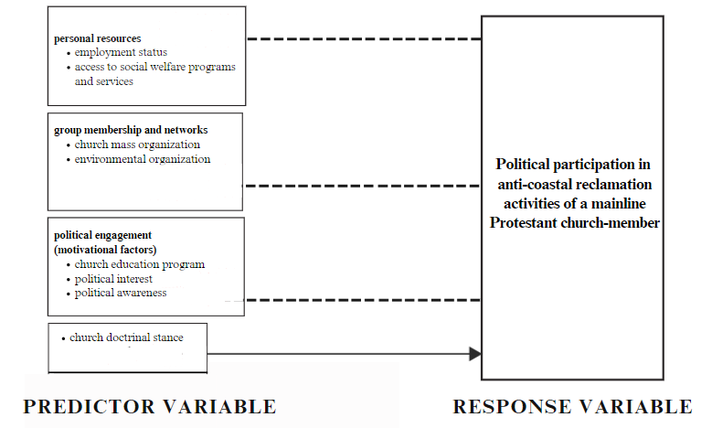

**Figure 6.1**Modified schematic diagram of the study

The arrowed line for the independent variable of the study, church doctrinal stance signifies the predictor as significant in terms of logistic regression analysis. On the other hand, the broken lines, which links predictor variables which did not passed the 5% level of significance in the Wald’s Chi-squared test, represents influential association in terms of supporting literature, Spearman’s rho correlation, and thematic analysis of the key informant interviews. These variables can be considered by future researchers in providing: (i) a furnished logistic regression model on predicting political participation among Bacolod-based mainline Protestant church members in anti-coastal reclamation activities, and (ii) a thorough comparative study for each mainline Protestant denomination which treats the sample denomination independently.

**Recommendations for further research**

* The study only focused on determining political participation in five mainline Protestant denominations in Bacolod City, Negros Occidental—the Convention of Philippine Baptist Churches, the United Church of Christ in the Philippines, the United Methodist Church, the Salvation Army and the Philippine Independent Church. Considering how evangelicals and fundamentalist Protestant denominations are also present in the said vicinity, further research could be conducted to evaluate political participation in anti-coastal reclamation movements within the said faith spectrum.
* Considering how the significant Spearman correlations failed to qualify in the final logistic regression model, it is interesting for practitioners of the social sciences to look into these correlations—political interest, political awareness and proximity as motivational and demographic predictors that could influence political participation of an individual in anti-coastal reclamation movements.
* There is a need to include document analysis particularly in assessing the posture of church education programs amongst mainline Protestant denominations in Bacolod City, Negros Occidental. The research instrument utilized in this study only limited to key informant interviews and a self-administered survey.
* For community organizers and advocates of civic society organizations specializing on alliance-building and group networks: church affiliation and doctrine of a mainline Protestant church-member could be utilized as indicator in assessing the likelihood for a church-member to engage (or not engage) in sociopolitical and civic activities. Community organizers can create a denominational profile of Bacolod mainline Protestant churches in terms of sociocivic engagement based on church doctrinal stance. The profile relayed either in educational materials can provide awareness and avenues of discussion for ecumenical discourse of mainline Protestant sociocivic activities.
* Community organizers can further look into typologies in church-polity of mainline Protestantism: (i) congregational (as expressed in the United Church of Christ and the Convention of Philippine Baptist Churches on which the local church is given autonomy in decision-making), (ii) episcopal (as evident in the Philippine Independent Church on which the local parish is the fundamental unit of the denomination), and (iii) connexional (as expressed in Methodist denominations of the study where a general conference acts as the supreme decision-making body of the church). While decentralized elements are integral under congregational and episcopal arrangements, centralization persists as a trend for Methodist denominations following a connexional form of church government; as such, there is an increment of difficulty for local congregations to develop policies framed within the context and struggles of their respective communities. The nature of church polity can be added on the church denominational profile.

**References**

Aguilan, V. (2016). Mission and Climate Justice: Struggling with God’s Creation. Global

Perspectives on Mission Theology and Mission Practice. *United Evangelical Conference*

Aoanan, M. G. (2009). NCC Philippines and Ecumenism. *CTC bulletin*, *25*(1/2), 81-85.

Baum, Christopher F. An introduction to modern econometrics using Stata. Stata press, 2006.

Brady, Henry E., Sidney Verba, and Kay Lehman Schlozman. "Beyond SES: A resource model of political participation." American political science review 89.2 (1995): 271-294.

Bunda, Nestor D. A mission history of the Philippine Baptist churches 1898-1998 from a Philippine perspective. Verlag an der Lottbek, 1999.

Cohen, Jean. "Trust, voluntary association and workable democracy: the contemporary American discourse of civil society." Democracy and trust 233 (1999): 237.

Dalton, Russell J. Citizen politics: Public opinion and political parties in advanced industrial democracies. Cq Press, 2013.

DCMI-Phil. A Letter of Environment Protection from NCCP retrieved from

http://www.dcmiphil.org/Letter_from_NCCP.pdf

IFI. General framework of the three-year rolling plan (2011-2014). Retrieved from

ifi.ph/www/three-year-rolling-plan

Kriesi, Hanspeter. "Political mobilization in times of crises: The relationship between economic and political crises." Austerity and Protest. Routledge, 2016. 19-33.

Ledesma, RJ. Banago residents launch anti-reclamation alliance. (2022) Paghimutad Negros

Miller, Arthur H., et al. "Group consciousness and political participation." American journal of political science (1981): 494-511.

Mills, Geoffrey E., and Lorraine R. Gay. Educational research: Competencies for analysis and applications. Pearson. One Lake Street, Upper Saddle River, New Jersey 07458, 2019.

Moody, Michael. "Caring for Creation: Environmental Advocacy by Mainline Protestant Organizations." The quiet hand of God. University of California Press, 2002. 237-264.

Potgieter, Elnari. Predictors of political participation in new democracies: a comparative study. Diss.Stellenbosch: Stellenbosch University, 2013.

Putnam, Robert. "The prosperous community: Social capital and public life." The American 4 (1993).

Putnam, Robert D. Bowling alone: The collapse and revival of American community. Simon and schuster, 2000.

Sparks, Aaron. Reducing Distance to Increase Action: How psychological proximity drives activism. Diss. UC Santa Barbara, 2017.

Samillano, Chrysee G. “Bacolod Reclamation Project Faces Opposition.” Visayan Daily Star. 2022 retrieved from (https://visayandailystar.com/bacolod-reclamation-project-faces-opposition/).

Tolles, Juliana, and William J. Meurer. "Logistic regression: relating patient characteristics to outcomes." Jama 316.5 (2016): 533-534.

Weyermüller, Astrid. Philippines: Lutheran Church Holds Youth Climate Action Summit, The Lutheran World Federation. 2020 Available at: https://www.lutheranworld.org/news/philippines- lutheran-church-holds-youth-climate-action-summit